**HOSPITAL DATABASE**

**Creating Database:**

create database hospital;

**Using database:**

>use hospital;

**Creating tables:**

1. **PATIENT TABLE**

create table patient

(P_id varchar(10) primary key,

P_name varchar(20) not null,

P_dob varchar(10),

P_phno varchar(10) unique,

G_det varchar(10),

B_grp varchar(3));

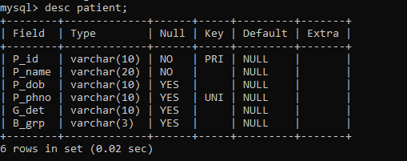

1. **DEPARTMENT TABLE**

create table department

(dept_id varchar(5) primary key,

d_name varchar(30) not null,

head varchar(20),

No_of_rooms int);

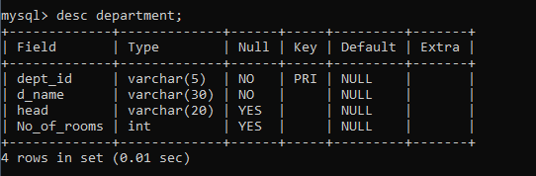

1. **NURSE TABLE**

create table nurse

(n_id varchar(10) primary key,

n_name varchar(20) not null,

shift varchar(3),

dept_id varchar(5),

foreign key(dept_id) references department(dept_id));

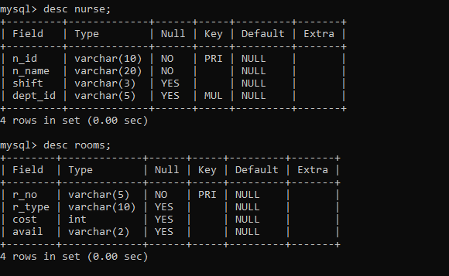

1. **DOCTOR TABLE**

create table doctor

(d_id varchar(10) primary key,

d_name varchar(20) not null,

d_age int,

d_phno varchar(10) unique,

d_type varchar(10),

dept_id varchar(5),

foreign key(dept_id) references department(dept_id));

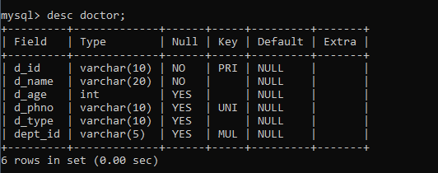

1. **NURSE TABLE**

create table nurse

(n_id varchar(10) primary key,

n_name varchar(20) not null,

shift varchar(3),

dept_id varchar(5),

foreign key(dept_id) references department(dept_id));



1. **ROOMS TABLE**

create table rooms

(r_no varchar(5) primary key,

r_type varchar(10),

cost int,

avail varchar(2));



1. **TREATMENT TABLE**

create table treatment

(p_id varchar(10),

d_id varchar(10),

n_id varchar(10),

r_no varchar(5),

foreign key(p_id) references patient(p_id),

foreign key(d_id) references doctor(d_id),

foreign key(n_id) references nurse(n_id),

foreign key(r_no) references rooms(r_no),

illness varchar(30) not null,

t_type varchar(20));

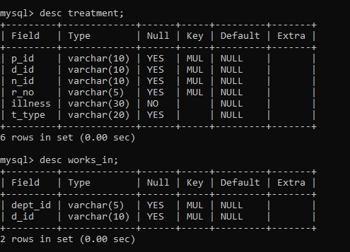

1. **WORKS_IN TABLE**

create table works_in

(dept_id varchar(5),

foreign key(dept_id) references department(dept_id),

d_id varchar(10),

foreign key(d_id) references doctor(d_id));



**Inserting Values:**

insert into patient values('P001','Raj','18-07-1996','9876543210','9876543219','A+');

insert into patient values('P002','Monica','29-09-1954','8765432109','8765432198','B+');

insert into patient values('P003','Haley','02-03-1947','7654321098','7654321987','AB+');

insert into patient values('P004','Diya','15-01-2001','6543210987','6543219876','A+');

insert into patient values('P005','Shiva','31-10-1987','5432109876','5432198765','O-');

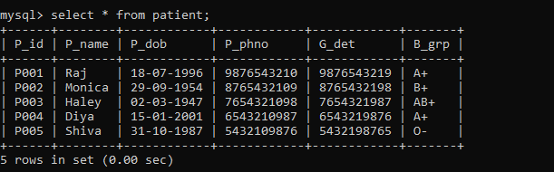

insert into department values('D1001','General','Ram Krishna',25);

insert into department values('D1000','Cardiology','Lakshmi',10);

insert into department values('D1017','Surgery','Shekhar',7);

insert into department values('D1022','Dermatology','Phoebe',3);

insert into department values('D1051','Orthopedic','Yogesh',5);

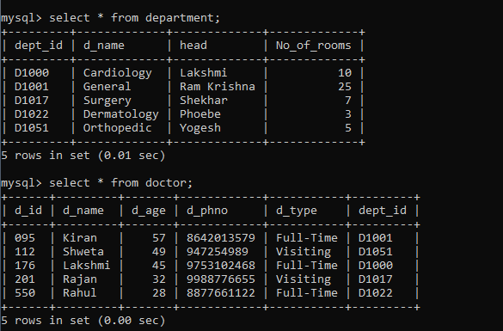

insert into doctor values('176','Lakshmi','45','9753102468','Full-Time','D1000');

insert into doctor values('201','Rajan','32','9988776655','Visiting','D1017');

insert into doctor values('550','Rahul','28','8877661122','Full-Time','D1022');

insert into doctor values('095','Kiran','57','8642013579','Full-Time','D1001');

insert into doctor values('112','Shweta','49','947254989','Visiting','D1051');



insert into nurse values('N420','Meena','M','D1051');

insert into nurse values('N473','Kavitha','M','D1017');

insert into nurse values('N429','Thomas','N','D1001');

insert into nurse values('N456','Angel','A','D1022');

insert into nurse values('N432','Priya','N','D1017');

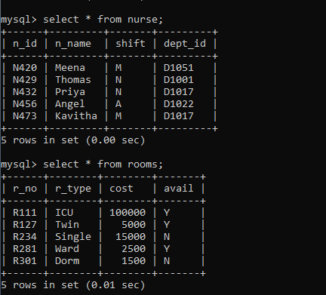

insert into rooms values('R111','ICU',100000,'Y');

insert into rooms values('R127','Twin',5000,'Y');

insert into rooms values('R234','Single',15000,'N');

insert into rooms values('R281','Ward',2500,'Y');

insert into rooms values('R301','Dorm',1500,'N');



insert into treatment values('P001','095',NULL,'R281','Fever','Consult');

insert into treatment values('P002','201','N473','R111','Hernia','Surgery');

insert into treatment values('P003','112','N420','R281','Fracture','Cast');

insert into treatment values('P004','550',NULL,'R301','Burns','Medication');

insert into treatment values('P005','176','N429','R111','Cardiac Arrest','Surgery');

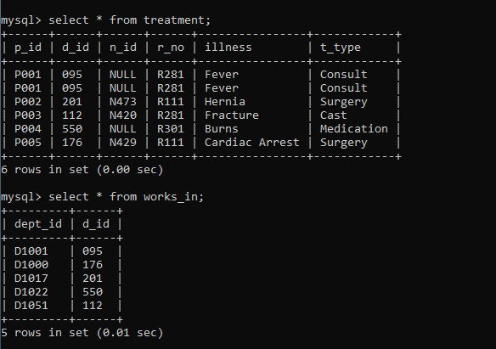

insert into works_in values('D1001','095');

insert into works_in values('D1000','176');

insert into works_in values('D1017','201');

insert into works_in values('D1022','550');

insert into works_in values('D1051','112');



**Queries:**

1. List patient details who are treated with surgery:

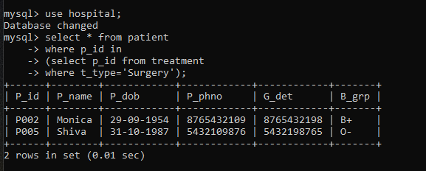

1. List all the doctors whose age is greater than 40 and work as a full-time doctor:

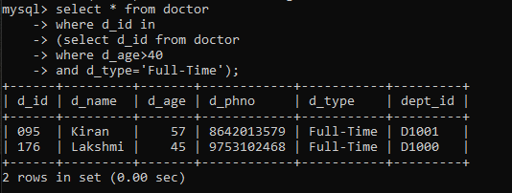

1. List details of rooms and patients based on room type:

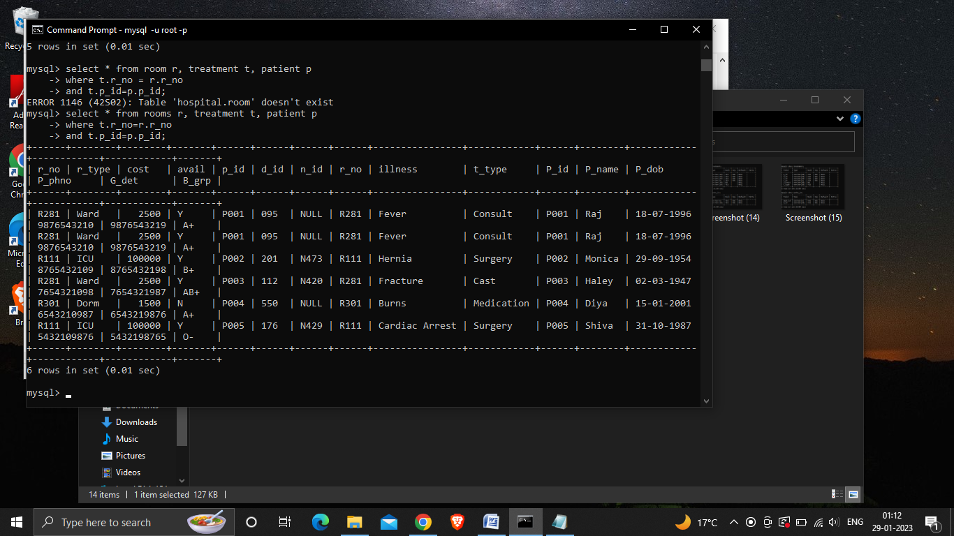

1. Create a view to display the patient name based on room and treatment type:

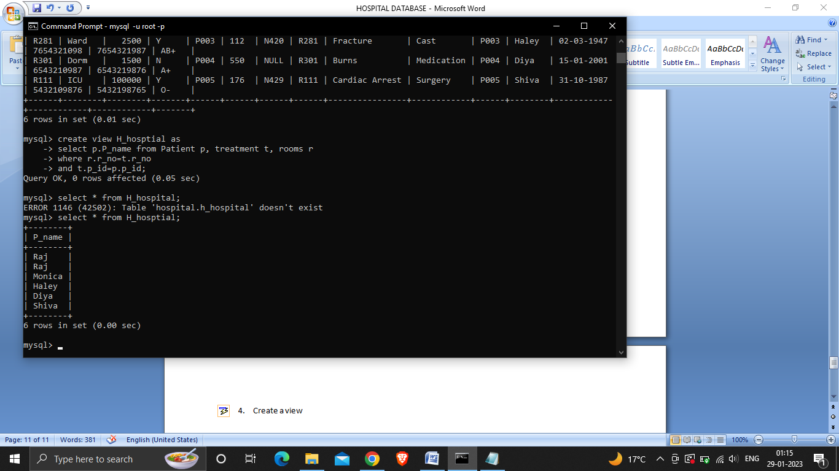

1. Display the room number that is being used for patient consult:

